HW 3 - Electronic Voting and MUX’s

Jonathan Schwartz

Section 003L

TA: Conner Rickermann

Date submitted: 3/18/2021

**Theory**

Multiplexers are a type of chip which take control bits and minterm inputs and have a single output. The control bits determine which input bit is going to be chosen from the minterm inputs, and output a single output based on the control bits which “control” the input. The minterm inputs may be a function of a separate input as well, for example, the minterms as a function of D, based on the control inputs S1, and S0 could be m0-m3 = 0,D,D,1 if m0 is always off, m1 and m2 are equivalent to the input, D, and m3 is always 1.

To derive the truth tables for these multiplexers, I first sorted the inputs by the control inputs, and put the functional input on the left and the output, f, on the right. This allowed me to, as a function of the functional input, D, have the specific output based on the control inputs choosing this input. The output, f, based on the control inputs can be defined for each input minterm as a function of D.

**Truth Table for 4-1 MUX**

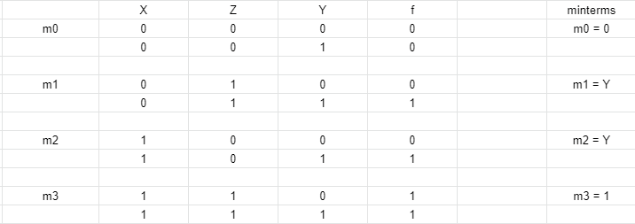

**Truth Table for 8-1 MUX**

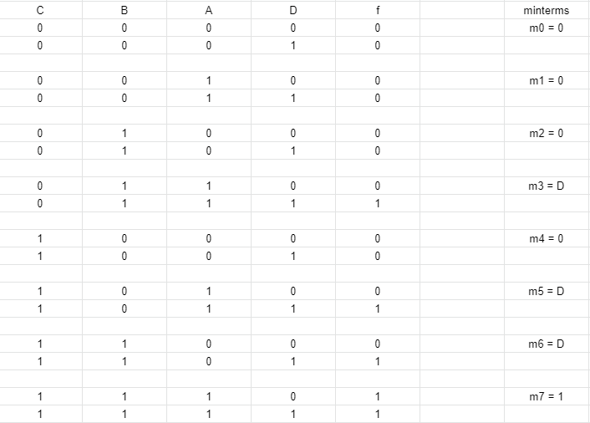

We require “dummy inputs” when each 4-1 unit includes 2 multiplexers because there is only one set of control bits on each chip, so, because the outputs are the same, given the same control bits, we must have separate multiplexers in order to have differing outputs and not have duplicate votes.

**Discussion**

With this lab, I learned how outputs of functions can be predetermined as the minterms of a multiplexer and utilized based on the control bits. This allows for a seemingly simplified circuit, as the single chip can account for what would have been many chips working together in a more complex circuit.

**Picture**

